**DE LA SALLE UNIVERSITY - MANILA**

2401 Taft Avenue, Manila

Final Project in

**LBYCPA1**

**JIGSAW PUZZLE**

___________________________________

A Term Project

Presented to Mr. Ruiz, Ramon

___________________________________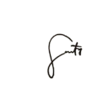

by

Santos, Tyra B. -

SHI, HONGXIAO- 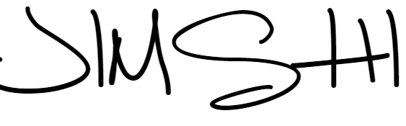

EQ1

Monday & Friday 7:30am - 10:30am

April, 2023

# Introduction

## Background of the Study

## The goal of the research is to create a puzzle game in Python using the Tkinter package. Rearranging image blocks in the puzzle game results in a finished image. Users of all ages enjoy playing this kind of game because it may be both entertaining and challenging.

## The significance of this study rests in its ability to advance knowledge about Python GUI development utilizing the Tkinter library. Making a puzzle game can be used as a concrete example to highlight the features and functionality of Tkinter, a popular Python library for constructing GUI applications.

## .

## Problem Statement

The study also intends to advance the fields of instructional tools and gaming development. Puzzle games have a reputation for enhancing cognitive abilities like spatial reasoning, critical thinking, and problem-solving. The creation of a puzzle game with Tkinter can offer users a useful educational tool to enhance their cognitive abilities in a pleasant and engaging way.

The study fills a gap in the body of knowledge by offering a useful Tkinter implementation of a puzzle game. Although Tkinter has a wide range of tutorials and examples, there is little information on precisely using this library to create puzzle games. This study solves this gap by offering a detailed explanation of how to create a puzzle game in Python using Tkinter.

## Objectives

## C.1 General Objective

To develop a puzzle game using Tkinter GUI library in Python.

**C.2** **Specific Objectives**

1. To create a GUI window with a canvas to display the puzzle game board.
2. To implement functionality for shuffling and rearranging the puzzle pieces on the board by capturing mouse clicks.
3. To display the number of steps taken to solve the puzzle.
4. To implement a win condition and display a congratulatory message upon successfully solving the puzzle.
5. To provide an option to restart the game with a button click.

## Significance of the Project

* Developing a puzzle game in Python using the Tkinter GUI package offers the chance to hone programming abilities, particularly in the areas of GUI construction, event management, and game logic implementation.
* Developing a puzzle game entails inventing algorithms for shuffle and reshuffle puzzle pieces, putting game logic into place, and testing for win conditions. This is problem-solving practice. This assignment provides an opportunity to practice logical reasoning and problem-solving techniques.
* Tkinter is a popular GUI package for Python, and this project gives you practical experience creating a graphical user interface for a game. Understanding ideas related to GUI development, such as widgets, event handling, and layout management, is aided by this.
* Giving players entertainment value: Puzzle games are well-liked and give players entertainment value. Tkinter makes it possible to create puzzle games that are entertaining for users and that are entertaining and interesting to play.

# Review of Related Literature

* ”Game Development with Python and Tkinter" by Harrison Kinsley and Will McGugan: This book provides an in-depth guide to developing games using Python and Tkinter, including topics such as creating GUIs, handling events, and implementing game mechanics.
* "Python Game Programming By Example" by Alejandro Rodas de Paz: This book focuses on developing games using Python and various libraries, including Tkinter.
* "Python GUI Programming with Tkinter" by Alan D. Moore: This book specifically focuses on GUI development using Tkinter, covering topics such as widgets, event handling, and layout management.

# Methodology.

## Conceptual Framework – IPO Chart (Input-Process-Output-Chart)

Input:

Mouse click events on the canvas (left button)

Button click event for "Restart" button

Process:

The code defines the graphical user interface (GUI) using the tkinter library in Python.

It loads external images for the puzzle pieces and creates a canvas to display the puzzle.

It defines a Square class to represent each puzzle piece and its properties.

It initializes the puzzle board with shuffled puzzle pieces.

It defines functions to draw the GUI elements, handle mouse click events, check for a win condition, and restart the game.

It binds mouse click events to the canvas and button click events to the "Restart" button.

It uses the tkinter message box to display a congratulatory message when the game is won.

Output:

Display of the GUI elements, including the canvas with the puzzle pieces arranged on the board.

Display of the number of steps taken to solve the puzzle.

Display of a congratulatory message when the puzzle is solved.

## Hierarchy Chart (Refer to the lecture on modules)

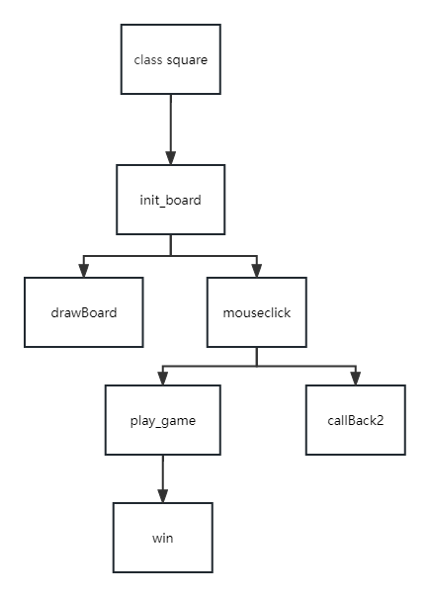

## Flowchart

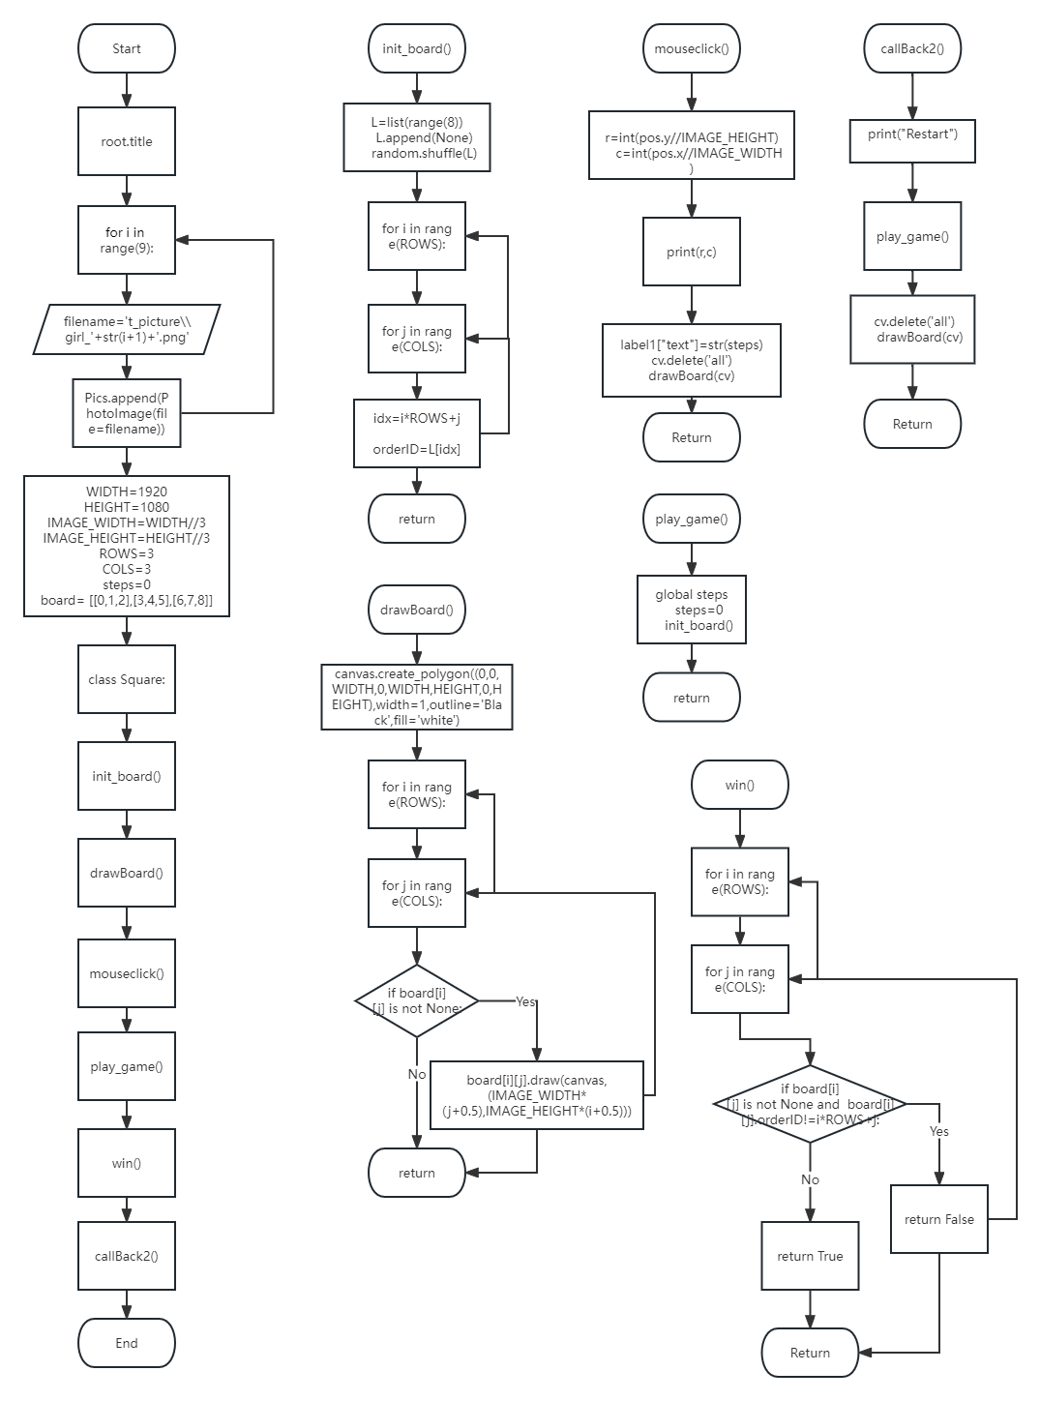

## Pseudocode

1. Import the necessary modules: tkinter, tkinter. messagebox, and random.

2. Create a Tkinter window with the title "Jigsaw Puzzle".

3. Define constants for the canvas size, image block size, rows and columns of the board, and steps.

4. Define a Square class to represent the image blocks.

5. Create a function to initialize the game board by shuffling the image block positions.

6. Create a function to reset the game.

7. Create a function to draw the game board on the canvas.

8. Create a function to handle mouse clicks on the canvas.

9. Create a function to check if the game has been won.

10. Create a function to handle the "Restart" button click event.

11. Create a canvas and button widgets in the Tkinter window, and bind the canvas to the mouse click event.

12. Call the play_game() function to start a new game and draw the initial game board on the canvas.

13. Start the Tkinter main event loop.

# Results

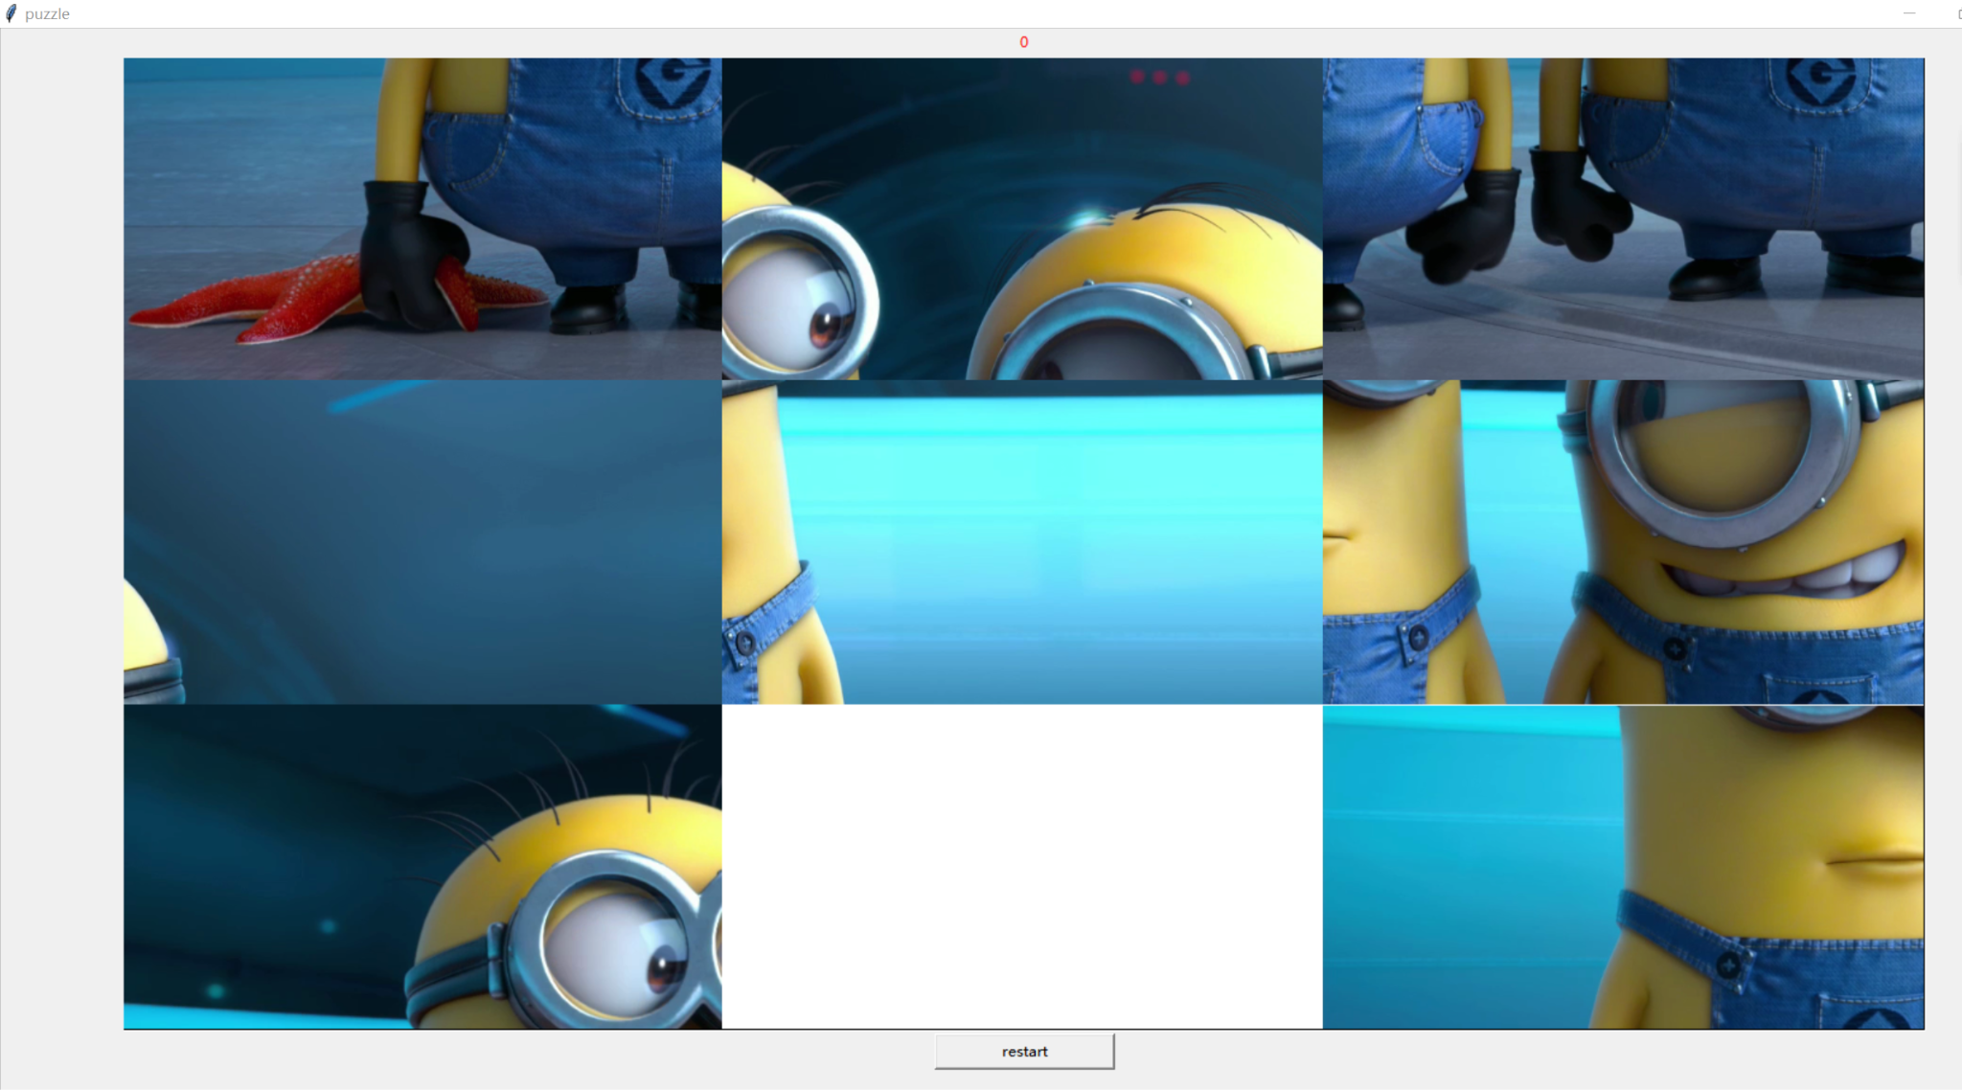

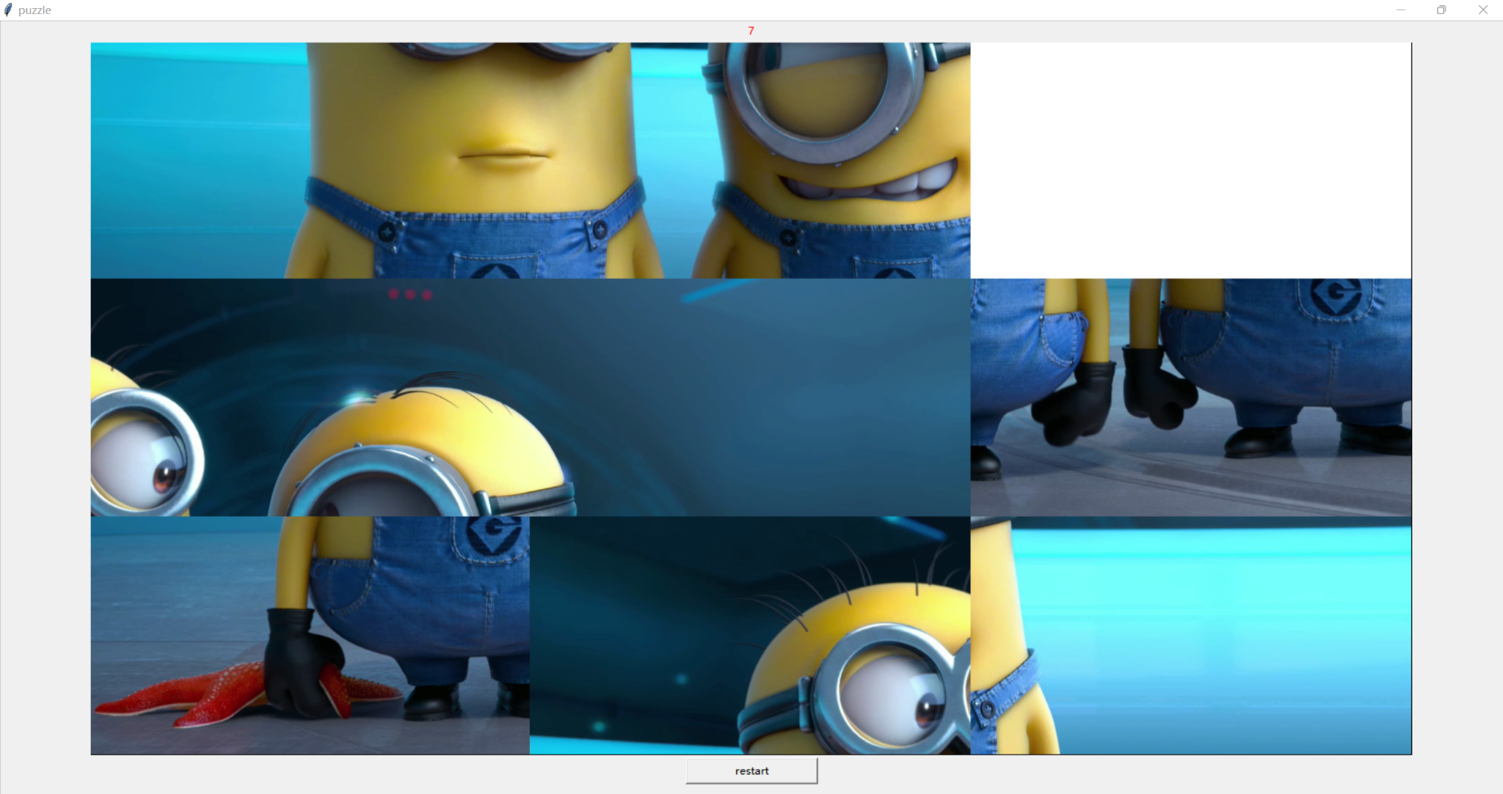

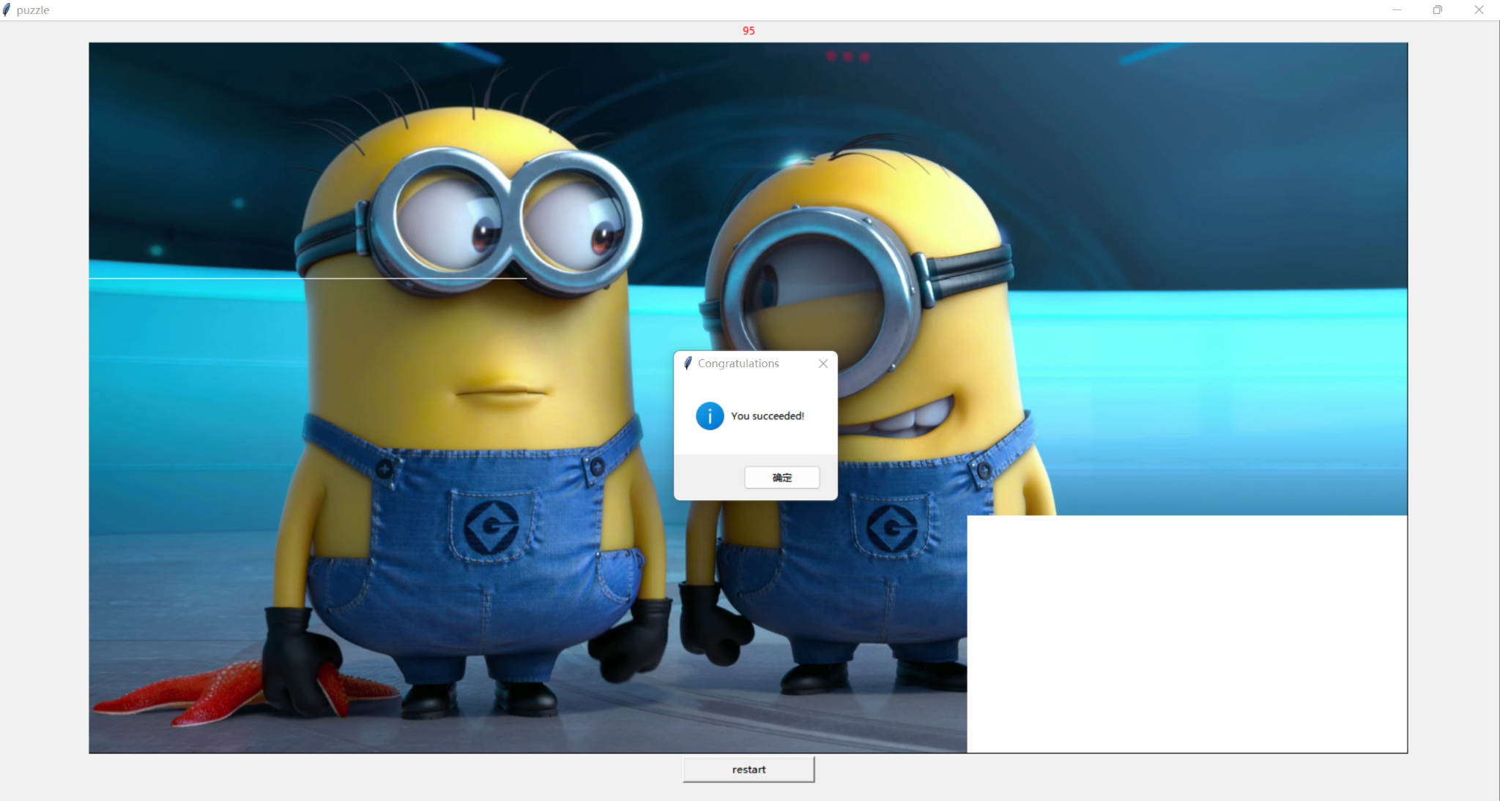

# Discussion of Results

The code is a Python program that uses the Tkinter toolkit for the graphical user interface (GUI) to construct a sliding puzzle game. The game consists of a 3x3 grid of scrambled image blocks that the player must rearrange to form the original image.

Overall, the code implements a basic sliding puzzle game using Tkinter, with features for shuffling image blocks, creating the game interface, handling player input, restarting the game, and checking for a win condition. However, certain enhancements might be implemented, such as adding error handling for user input, upgrading the game interface design, and providing additional user feedback during the game.

# Analysis, Conclusion and Future Directives

* The code is a simple implementation of a puzzle game using the Tkinter library in Python. The game involves shuffling and rearranging image tiles to complete a picture. The code uses a canvas to draw the game board, buttons for restarting the game, and labels to display the number of steps taken by the player.
* The game logic is implemented using a 2D list called "board" to represent the puzzle board, where each element in the list represents an image tile. The "Square" class is used to represent each image tile, and the "draw" method of the "Square" class is used to draw the image on the canvas.
* The game flow is as follows:

1. The puzzle board is initialized by shuffling the image tiles using the "init_board" function.
2. The game board is drawn on the canvas using the "drawBoard" function.
3. The player can click on the canvas to move the image tiles and rearrange them.
4. The game checks for a win condition using the "win" function after each move.
5. If the player wins, a message box is displayed to congratulate the player.

.

# References

Vinish Kapoor(2023)*How to Create a Window in Python Using Tkinter?*

<https://www.foxinfotech.org/how-to-create-window-in-python-using-tkinter>

Rebecca Stone(2019)*Three Ways of Storing and Accessing Lots of Images in Python*

<https://realpython.com/storing-images-in-python/>

Educational Answers Team(2023)*How to define classes in Python*

<https://www.educative.io/answers/how-to-define-classes-in-python>

Thread starter master master(2010)*Python - drawing a game board*

<https://www.thehelper.net/threads/python-drawing-a-game-board.135654/>

Karan Gupta5,*Handle mouse events in Python – OpenCV*

<https://www.geeksforgeeks.org/handle-mouse-events-in-python-opencv/>

David Amos,*Python GUI Programming With Tkinter*

<https://realpython.com/python-gui-tkinter/>

Kiran Kumar Panigrahi(2021)*How to run an infinite loop in Tkinter?*

<https://www.tutorialspoint.com/how-to-run-an-infinite-loop-in-tkinter#>

# Appendices

## User’s Manual

* Interface: The game interface consists of a main window, a canvas holding a 3x3 image, a counter, and a "restart" button.
* Controls Use the left mouse button to click on an empty grid in the canvas to swap their positions until all the pieces are back in their original positions.
* Rules: The player needs to click on the blank grid to move the picture, and the game is over when the picture returns to its original position.
* Features: When you move the picture, the number of steps is recorded and displayed on the top of the interface. The "Restart" button is at the bottom of the program and it can be used to reset the game and start over. If the player completes the puzzle, a message box pops up congratulating the player.
* Usage: To play the game, the player needs to run the code and the game window will open.

## Source Code

from tkinter.messagebox import *

from tkinter import

import random

root=Tk('jigsaw puzzle')

root.title("puzzle")

# load external image

Pics=[]

for i in range(9):

filename='t_picture\\cute_'+str(i+1)+'.png'

Pics.append(PhotoImage(file=filename))

# define constants

# The size of the canvas

WIDTH=1500

HEIGHT=810

# The side length of the image block

IMAGE_WIDTH=WIDTH//3

IMAGE_HEIGHT=HEIGHT//3

# Number of rows and columns of the board

ROWS=3

COLS=3

# number of moving steps

steps=0

# save a list of all image blocks

board= [[0,1,2],

[3,4,5],

[6,7,8]]

#ImageBlock class

class Square:

def __init__(self,orderID):

self.orderID=orderID

def draw(self,canvas,board_pos):

img=Pics[self.orderID]

canvas.create_image(board_pos,image=img)

# Initialize the puzzle

def init_board():

# Scramble image block coordinates

L=list(range(8))

L.append(None)

random.shuffle(L)

# Fill the puzzle board

for i in range(ROWS):

for j in range(COLS):

idx=i*ROWS+j

orderID=L[idx]

if orderID is None:

board[i][j]=None

else:

board[i][j]=Square(orderID)

# reset game

def play_game():

global steps

steps=0

init_board()

# Draw the elements of the game interface

def drawBoard(canvas):

# draw black frame

canvas.create_polygon((0,0,WIDTH,0,WIDTH,HEIGHT,0,HEIGHT),width=1,outline='Black',fill='white')

# draw image blocks

for i in range(ROWS):

for j in range(COLS):

if board[i][j] is not None:

board[i][j].draw(canvas,(IMAGE_WIDTH*(j+0.5),IMAGE_HEIGHT*(i+0.5)))

def mouseclick(pos):

global steps

# Convert the click position to coordinates on the puzzle board

r=int(pos.y//IMAGE_HEIGHT)

c=int(pos.x//IMAGE_WIDTH)

print(r,c)

if r<3 and c<3:

if board[r][c] is None:

return

else:

current_square=board[r][c]

if r-1>=0 and board[r-1][c] is None:

board[r][c]=None

board[r-1][c]=current_square

steps+=1

elif c+1<=2 and board[r][c+1] is None:

board[r][c] = None

board[r][c+1] = current_square

steps += 1

elif r+1<=2 and board[r+1][c] is None:

board[r][c] = None

board[r+1][c] = current_square

steps += 1

elif c-1>=0 and board[r][c-1] is None:

board[r][c] = None

board[r][c-1] = current_square

steps += 1

#print(board)

label1["text"]=str(steps)

cv.delete('all')

drawBoard(cv)

if win():

showinfo(title="Congratulations",message="You succeeded!")

def win():

for i in range(ROWS):

for j in range(COLS):

if board[i][j] is not None and board[i][j].orderID!=i*ROWS+j:

return False

return True

def callBack2():

print("restart")

play_game()

cv.delete('all')

drawBoard(cv)

# set window

cv=Canvas(root,bg='white',width=WIDTH,height=HEIGHT)

b1=Button(root,text="restart",command=callBack2,width=20)

label1=Label(root,text="0",fg="red",width=20)

label1.pack()

cv.bind("<Button-1>",mouseclick)

cv.pack()

b1.pack()

play_game()

drawBoard(cv)

root.mainloop()

1. **Work breakdown**

| Student Name | Tasks Assigned | Percentage of the Work Contribution |
| --- | --- | --- |
| SHI,HONGXIAO | Module 1 – login authentication  Module 2 – the process of printing the receipt  Pseudocode  Review of Related Literature  Flowchart | 60% |
| Student 2 | Module 3 – the process of quiz evaluation  Methodology  Record  Powerpoint  Result  Debug and modify code  Post | 40% |

1. **Personal Data Sheet**

